**Appropriate Location for a New Restaurant**

1. **Introduction**

Toronto is a multicultural city and also financial capital for 10th largest economy in the world i.e. Canada. One of my client wants to open a new restaurant in city of Toronto, Canada. I am being a consultant to my client have to provide him few viable location for the restaurant and also the type of restaurant.

1. **Business Problem**

My client is more concerned about the location of the restaurant. As Toronto being a multicultural city. It is full of restaurants serving cuisines from all over the world. Toronto also has many neighbourhoods, 103 to be exact. Using Data Analysis it is my job to find a viable location, where competition would be less and there should be scope for growth and reputation. I have to decide in which neighbourhood my client should open a restaurant and which cuisines can be served in restaurant in order to capture likely customers or which cuisine type restaurant is missing in that neighbourhood.

1. **Data Requirment**

First of all Toronto neighbourhood data can be collected from Wikipedia including Postal Code and Name of the Neighbourhood. Then i will be using Geocoder to fetch latitude and longitude values for Toronto Neighbourhoods. As we are already aware of the Foursquare api. I will use foursquare api to fetch maximum number of the venues around all the neighbourhoods. Later analysis can be done on all type of venues and cuisine types to determine the probability of opening a restaurant.

1. **Exploratory Data Analysis**

Features of Toronto data sets are details of multiple neighbourhoods, boroughs and there latitude and longitude values. However, as we are using FourSquare API, which fetch the details of the nearby venues and their category. Hence we have achieved the count or frequency of occurrence of particular category of restaurant or venue.

The same can be sort according to their occurrence in the neighbourhood and can be visualized as given below for every borough.

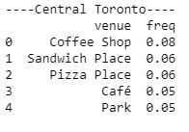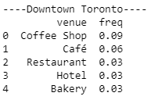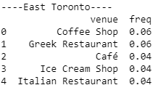

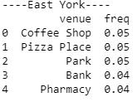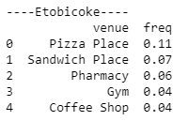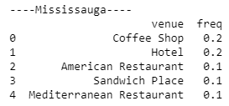

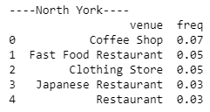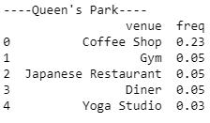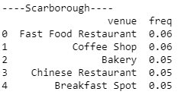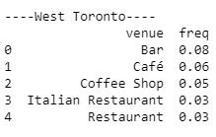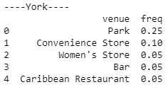

1. **Methodology Section**

The methodology I have used to cluster these venues is K means, as it divides the borough into five clusters, based on the occurrence of ten most common venues in the boroughs. It also describes the occurrence of coffee shops, pizza places, Bars, Indian restaurants and parks. These Datasets can be referenced in order to find a place or neighbourhood where a restaurant can be opened. We will further discuss the approach in Result and discussion section.

1. **Result**

As you have seen above details and images of borough with top five frequently occurring places. It is clear that what other restaurants are not in some specific borough. As you can see the Queen’s Park have high occurrence of Coffee Shops but no Indian restaurant. Similarly, Mississauga Region has very few Italian restaurants and more coffee shops. Also it is clear that Mississauga has less pizza stores in comparison to coffee shops. As Canada has cold and harsh weather, it is natural to have more coffee shops then ice cream shops.

1. **Discussion on result**

It is likely to discuss that decision on opening a restaurant and type of it can be inferred from the frequency of occurrence of venues in particular borough. Here we are ignoring the racial components and assuming that Canada is a multicultural society. There is possibility that some borough might not have more Indian people living there, and that could be the reason of having no Indian restaurant in that region.

It can be found from the details that Pizza Places are not in top 5 in most of the boroughs such as Mississauga, York, Scarborough and west Toronto.

1. **Conclusion**

It can be concluded that opening a Pizza Place in Mississauga region, or York region can be Profitable.